WiRE-FRAME

FLIGHT FARE PREDICTOR

Table of Contents

1.HOME PAGE 3

1.1 What is “predict fligh price”? 3

1.2 What is in the header? 3

1.3 What is Results Section? 4

# 1.HOME PAGE

We have created home page section in such a way that user will feel very easy to interact with our product. Here is how our home page is

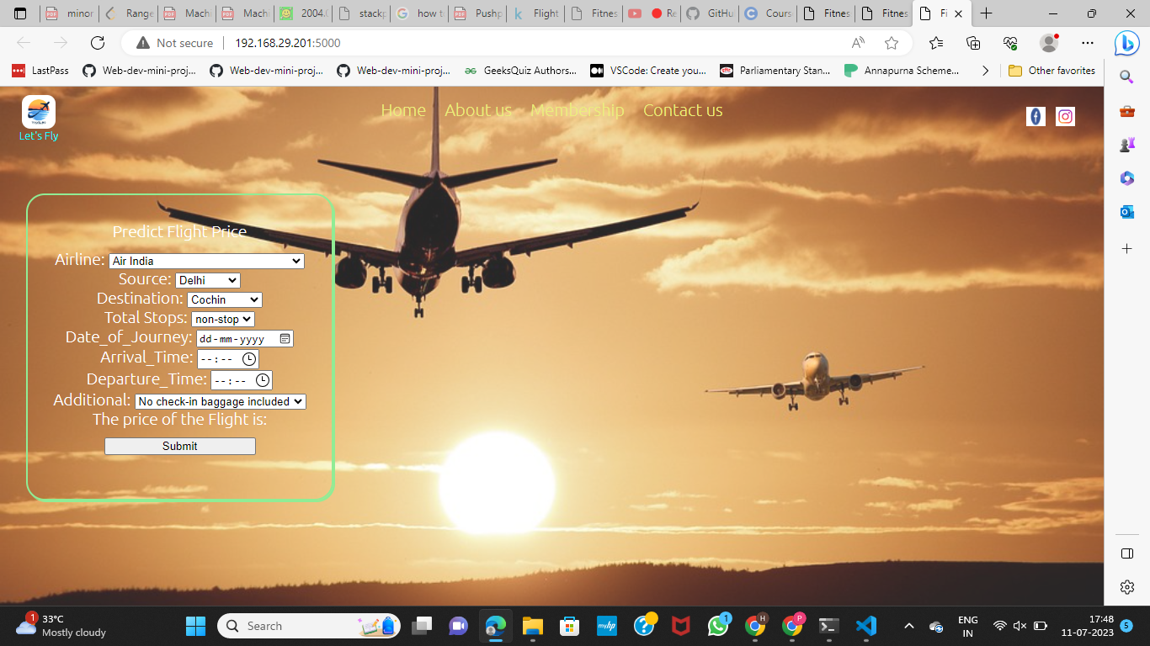

## What is “predict fligh price.”?

Ans) In this place user have to fill his/her information related to the flight they want to board it includes source, destination of flight, arrival and departure time of flight, Airline name, number of stops and other additional information like additional baggages, food etc.

.

## What is in the header?

Ans) Header of this page includes logo of website on top left corner, social media profile links on top right corner and in the middle we have Home button, Membership button to take membership, Contact Us button to know our contact details and About Us to know more about our project and website.

## 1.3 What is Results Section?

Ans) Once the user will fill all the details in data fields of predict flight price box, he/she will get to know the estimated price of that flight.